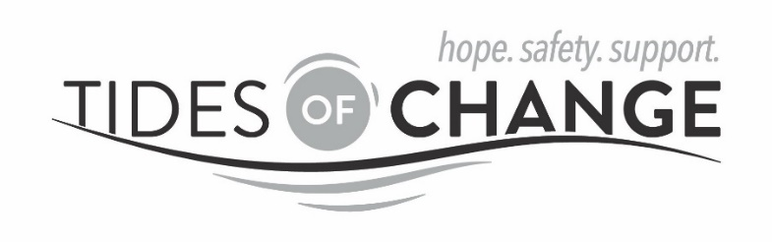

POSITION TITLE: Bilingual Health Programs Advocate
HOURS: Monday-Friday 9am-5pm, with rotating on-call duties on nights and weekends
(FTE) 1.0 FTE
REPORTS TO: Executive Director

Tides of Change (ToC) is a private non-profit organization established in 1982, serving Tillamook County, Oregon, and is the primary community-based advocacy service for survivors of domestic/dating violence, sexual violence, stalking and trafficking. Our services include a 24-hour helpline, a confidential shelter, a drop-in advocacy center, counseling, and therapeutic art and support groups.

Position Summary: The Bilingual Health Programs Advocate will be stationed ToC and will respond to healthcare community partner programs. The advocate is responsible for direct client services for victims of domestic/dating violence, sexual violence, stalking, and trafficking and providing consultations to healthcare community partners.

All persons of every race, ethnic background, spiritual belief, economic status, gender identity, sexual orientation, age or personal ability, are equally affirmed into membership, leadership and employment at Tides of Change and are welcomed and strongly encouraged to apply.

Primary Duties and Responsibilities:
- Provide emergency crisis intervention and case management services for individuals who are victims of intimate partner violence and sexual violence, including but not limited to safety planning, emergency shelter, food and transportation, civil legal assistance, advocacy, information and referral and connection with other community resources
- Work cooperatively with the Tillamook County Community Health Center, Nehalem Bay Health Center & Pharmacy, Tillamook Family Counseling Center and other health care providers and social service staff as indicated, with the goal of providing effective, coordinated services to VOCA grant-eligible victims of IPV
- Advocate for victims with partnering agency systems to ensure high quality services to survivors
- Provide outreach to survivors and community partners.
- Provide consultation to grant partners specifically healthcare providers related to Intimate Partner Violence
- Identify training and resource need related to Intimate Partner Violence for Health Program partners and make information available to Health Programs Coordinator
- Attend case management meetings to insure effective, holistic services
- Accompany Public Health and Home Visiting Programs staff on home visits, as indicated
- Develop proficiency with electronic medical record system as a part of co-location
- Collect data for reporting and evaluation purposes
- Provide front desk and reception coverage as needed/assigned
- Attend all grant required phone meetings, in-person meetings and trainings
- Participation in project evaluation.
- Participate in coverage of the Helpline after hours and weekends on a rotating schedule.

General Duties: (to be included on all job descriptions)
- Participate in various team projects including team meetings, coordination and implementation of pertinent activities, and other duties as necessary or assigned by supervisor
- Maintain reports and documentation consistent with ToC procedures and turn in all reports and documentation in a timely fashion
- Attend appropriate community meetings and participate in collaborative community projects
- Attend relevant trainings
- Contribute to creation of press releases and media materials for job-related projects
- Make necessary referrals to general ToC advocates, and maintain inter-agency communication

Qualifications and Skills-Required:
- Bilingual in English/Spanish with the ability to both read and write
- An understanding of domestic violence, sexual assault, and oppression
- B.A., or equivalent training and experience.
- Ability to work with diverse groups of people including all ages, races, backgrounds, religions, etc.
- Proficient computer skills as necessary to meet program objectives
- Reliable vehicle, current driver’s license and proof of insurance
- Strong organizational and recordkeeping skills
- Ability to work flexible hours and be self-motivated
- Demonstrated ability to provide empathetic direct services and advocacy for victims of IPV
- Strong communication and collaboration skills

Qualifications and Skills-Preferred:

- Knowledge of community health and social service programs
- Have demonstrated program planning skills
- Previous completion of a 40-hour Domestic and Sexual Violence Advocacy Training.
- Current Community Health Worker Certification

To Apply:
- Send your resume and cover letter to valerie@tidesofchangenw.org

